Register for Supplemental Instruction (SCI) Courses:

Get more out of your Science, Math, and Engineering classes!
The 22-23 SI Team

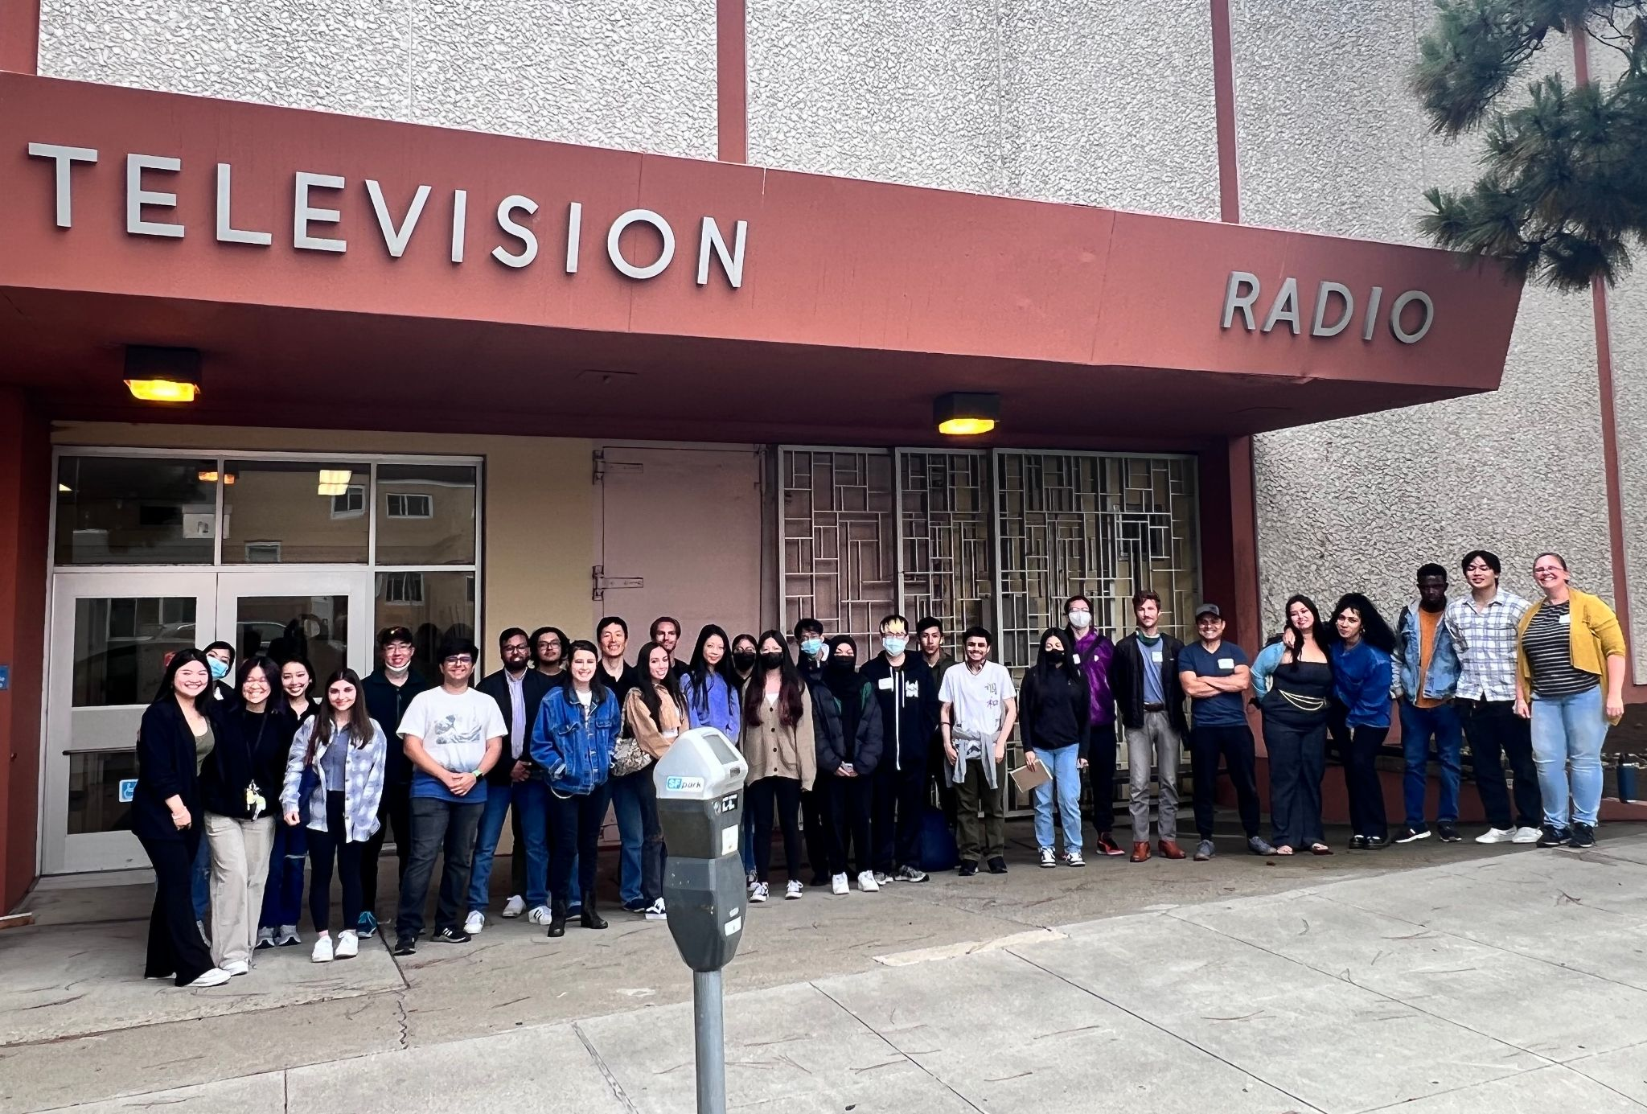
Learn how to study effectively and efficiently with your friends!

We run SCI courses to support students in introductory biology, chemistry, math, physics, and engineering courses at SFSU. Check the schedule of classes for specific offerings each semester!

What is a SCI course? SCI courses are small 1-unit classes that meet once per week for an hour and 40 minutes. Students work in small groups on practice problems and activities to support their learning in the parent course with the help of two friendly undergrad facilitators. There are no exams or homework in a SCI course: grades are based on class participation and in-class activities, so you must be able to attend the class meeting. Note that SCI classes are in-person, on-campus.

Why take a SCI course? Students who take SCI and attend every week earn on average a half-letter grade better are twice as likely to pass the parent course on their first try! Additionally, SCI helps you solidify your understanding, plan your study time, learn new study strategies, and make friends with other students in your class and in your major.

How do I sign up for a SCI course? Search the class schedule for courses under the prefix “SCI”, and check that it matches your parent course (for example, students in CHEM 115 take SCI 115). Enroll like you would in any other class, or attend the next class meeting to get a permission number.

More questions? Email Andrew Sturner, at asturner@sfsu.edu

Please include your name, student ID, and which SCI course(s) you are interested in the subject line.

Spring 2024 SCI Course Offerings

(times are subject to change, please check the class schedule for the most current information)

SCI Course | Parent Course | Meeting Time & Location | Facilitator 1 | Facilitator 2
SCI 111.01 | PHYS 111 | M 12-1:40PM, CA 126 | Madison Hales | Aaliyah Muhammad
SCI 115.01 | CHEM 115 | M 2-3:40PM, CA 126 | Matthew Basa | Tyler Cruz
SCI 115.02 | CHEM 115 | T 2-3:40PM, CA 126 | Esmeralda Garcia-Sanchez | Diya Patel
SCI 199.01 | MATH 199 | W 4-5:40PM, BH 35 | Meet Patel | Humaid Shams
SCI 205.01 | ENGR 205 | M 4-5:40PM, BH 35 | Basim Baylor | Michael Cabrera
SCI 215.01 | CHEM 215 | M 10-11:40AM, CA 126 | Emily Hernandez | Vivian Ho
SCI 215.02 | CHEM 215 | F 10-11:40AM, CA 126 | Wendy Ko | Destinee Lewis
SCI 220.01 | PHYS 220 | T 6-7:40PM, CA126 | Omshree Bharodiya | Ritesh Ritesh
SCI 226.01 | MATH 226 | M 6-7:40PM, BH 35 | Samarth Pandya | Yash Patel
SCI 226.02 | MATH 226 | W 12-1:40PM, CA 126 | Daniel Chang | Hinal Halani
SCI 227.01 | MATH 227 | Th 6-7:40PM, CA 126 | Justin Elcano | Ritesh Ritesh
SCI 228.01 | MATH 228 | W 10-11:40AM, CA 126 | Christian Camano | Taylor Hosepodarec
SCI 230.01 | BIOL 230 | W 2-3:40PM, CA 126 | Daniel Urista | Alisa Yu
SCI 234.01 | PHYS 230 | T 4-5:40PM, CA 126 | Sukrit Dhawan | Max Owens
SCI 240.01 | BIOL 240 | T 10-11:40AM, CA 126 | Nathalie Aquino | Brian Wong
SCI 305.01 | ENGR 305 | Th 8-9:40AM, CA 126 | Lang Cheng | Michael Decker
SCI 305.02 | ENGR 305 | F 2-3:40PM, CA 126 | Marco Anguiano | Michael Decker
SCI 333.01 | CHEM 233 | F 10-11:40AM, BH 35 | Lika Chhit | Celeste Rascon
SCI 335.01 | CHEM 335 | F 4-5:40PM, BH 35 | Charlie Gardner | Galilee Samuels
SCI 350.01 | BIOL 350 | Th 10-11:40AM, CA 126 | Madison Raub | Ileana Rodriguez

What do students think of SCI?

“Without this course I don't think I would have done as well just by studying on my own.” -SCI 215 student, Spring 2019

“SCI gave me confidence in my abilities.” -SCI 220 student, Spring 2018

“My group would give me different perspectives on a certain problem and would help me learn the concepts of the lessons better overall.” - SCI 226 student, Fall 2018

“Anytime there was a question the facilitators went above and beyond in order to make sure the concept in question was understood.” -SCI 115 student, Fall 2018

